**[Stroop Effect](https://en.wikipedia.org/wiki/Stroop_effect" \t "_blank) Report**

1. **What is our independent variable? What is our dependent variable?**

Our independent variable are types of conditions - congruent words condition and incongruent words condition. Our dependent variable is the time each person spends to finish the reading.

1. **What is an appropriate set of hypotheses for this task? What kind of statistical test do you expect to perform? Justify your choices.**

H0: there is no difference on time in two difference conditions

Ha: there is the difference on time in two difference conditions

H0: μd = 0 (μd :The population mean of the difference)

H1: μd ≠ 0

I will use dependent t-test. Because it’s good for testing paired samples when t-test is most commonly applied when the population standard deviation was unknown, such as two-conditions. You can use t-test to reject or accept your hypotheses.

1. **Report some descriptive statistics regarding this dataset. Include at least one measure of central tendency and at least one measure of variability.**

In the congruent condition, median is 14.37, the average is 14.05. In the incongruent condition, median is 21.02, and the average is 22.02。

In the congruent condition, standard deviation is **3.56** in the incongruent condition, that value is **4.80.**

1. **Provide one or two visualizations that show the distribution of the sample data. Write one or two sentences noting what you observe about the plot or plots.**

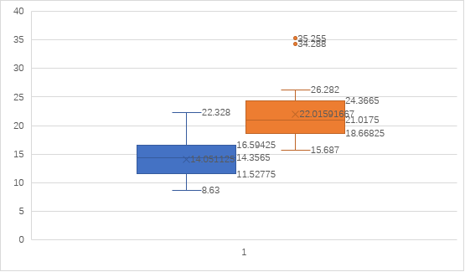

In this visualization, we can find the value of median, average, Q1, Q3, max, min of two conditions. And we also can find in the incongruent condition, there are two values outside of the box, which means they are abnormal

In this visualization, we can find the tendency that the time spend on incongruent condition is longer than congruent condition generally.

1. **5. Now, perform the statistical test and report your results. What is your confidence level and your critical statistic value? Do you reject the null hypothesis or fail to reject it? Come to a conclusion in terms of the experiment task. Did the results match up with your expectations?**

My confidence level is 95%，t-critical is +/- 2.07, standard error is 0.99, mean difference is -7.96, and t-statistical is -8.02. So, I reject the null hypothesis and the conclusion is there is the difference on time cost in two difference conditions. The results match up with my expectations

1. **Optional: What do you think is responsible for the effects observed? Can you think of an alternative or similar task that would result in a similar effect? Some research about the problem will be helpful for thinking about these two questions!**

In my opinion, I think the central tendency and visualization are helpful for the effects observed.

(Actually, I don’t understand the second problem, and what’s the effect means accurately, could you give me some hints or example?)

Reference:

1. The data and calculation process and some formula:

<https://docs.google.com/spreadsheets/d/1nUT3ndLTg6iqubCNg7INkn7d60TKq7a9mzyiPxdLTvI/edit?usp=sharing>

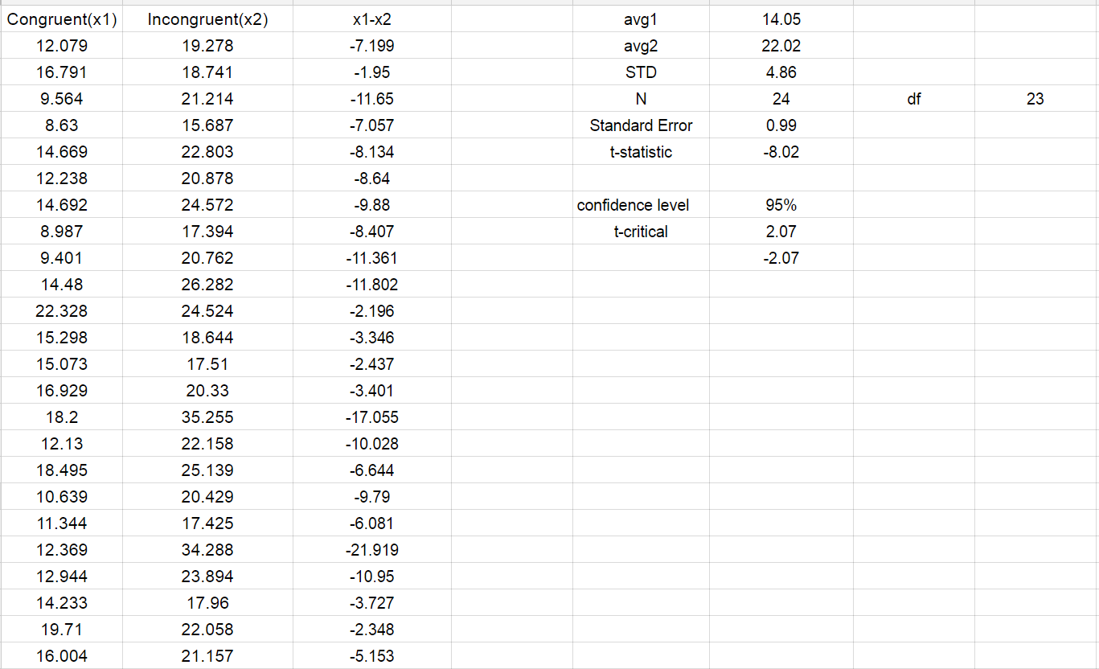

1. https://en.wikipedia.org/wiki/Stroop\_effect